|  |
| --- |
| Google Ad_Hours_Analysis_With_Python |
|  |
|  |
|  |

**Date : 20/06/2023**

|  |  |
| --- | --- |
| **Project Start Date - End Date** | * Start Date – 20 -06 -2023 * End Date – 20-06 2023 |
| **Objectives** | * To analyses how many people who clicked on the advertisement enrolled in our course * General exploratory analyses * General descriptive analyses |
| **Milestones accomplished the week of Start Date - End Date:** | * Descriptive analyses * Exploratory analyses * Classification of data with respect to term * DecisionTreeClassifier |
| **Milestones accomplished the week of Start Date - End Date** | * Data import * Data overview * Data preprocessing * Descriptive analysis. * linear regreesion * DecisionTreeClassifier. * Exploratory data analysis. * Main alogorithms * Correlations * Conclusion * Insights |
|  |  |
|  |  |
|  |  |

# **Contact Information**

This project is performed for educational purpose of under the guidance of Siddhivinayak Sir .

|  |  |
| --- | --- |
| **Project Manager**  Name : Siddhivinayak Phulwadkar  Mobile: 9028965955  Email: [siddhivinayakphulwadkar@gmail.com](mailto:siddhivinayakphulwadkar@gmail.com) | **Student Name**  Name : Veerbhadra Govind Lavharale  Mobile: 9607194266  Email: virbhadralavrale@gamil.com. |

# **Project Abstract**

The dataset is about showing … 1**. DATA IMPORT AND OVERVIEW.:- import data set by using pandas ,numpy seaboarn, by ploting use matpilot .pyplot. then overview the data how data big or small there is no null find** 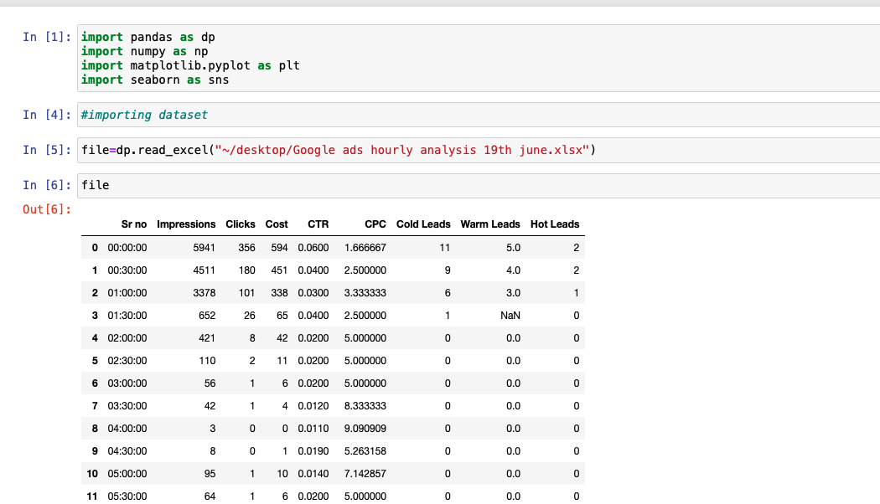

2**. DATA PREPROCESSING** :-

#check number of unique value from all data set

vs.isnull().sum()

#remove columns

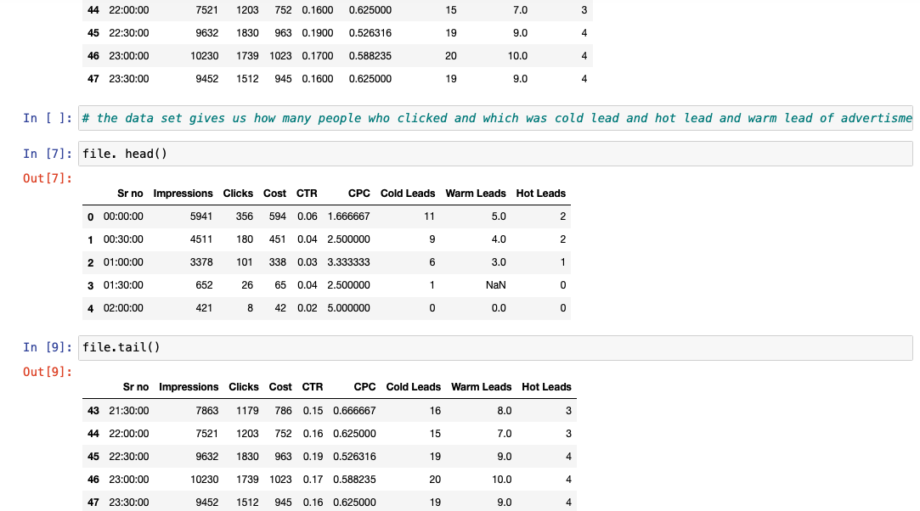

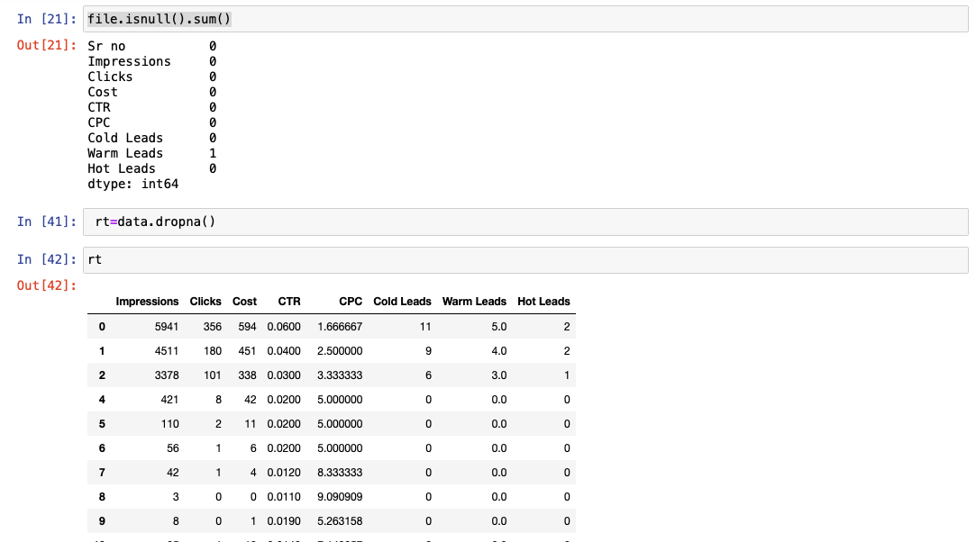**3.DESCRIPTIVE ANALYSIS.:-**

**It describe the information about data set like its std .** **deviation nad mean ,max and count etc**

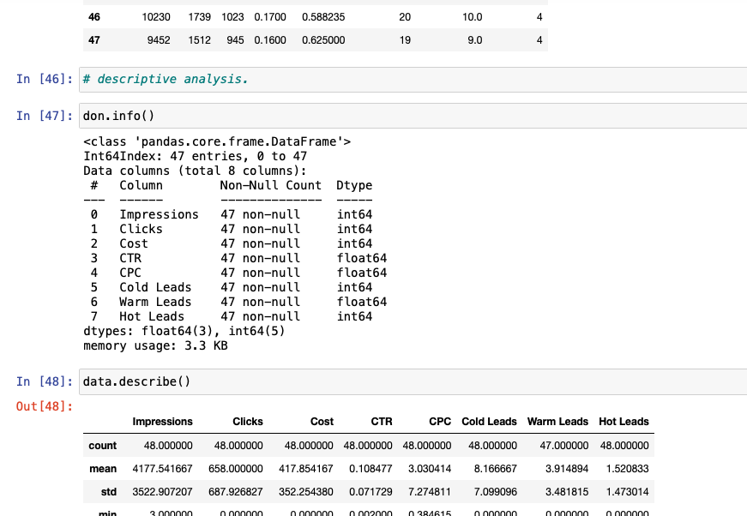

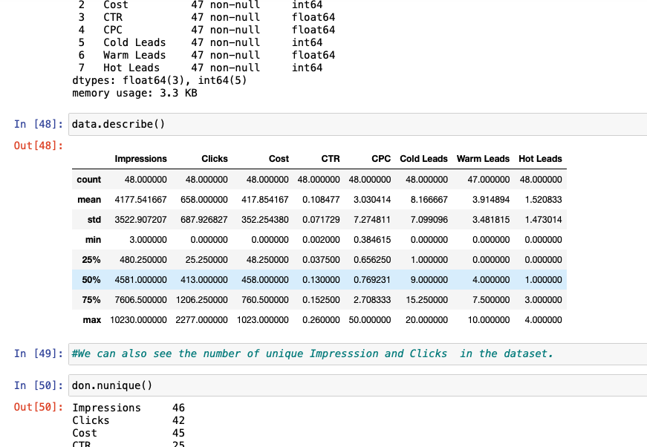

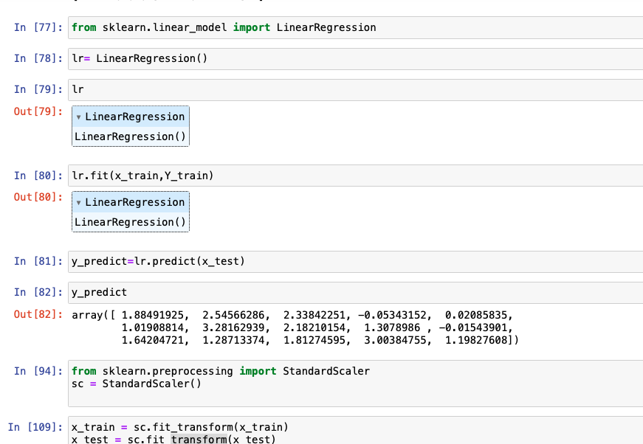

Linear regreesion.

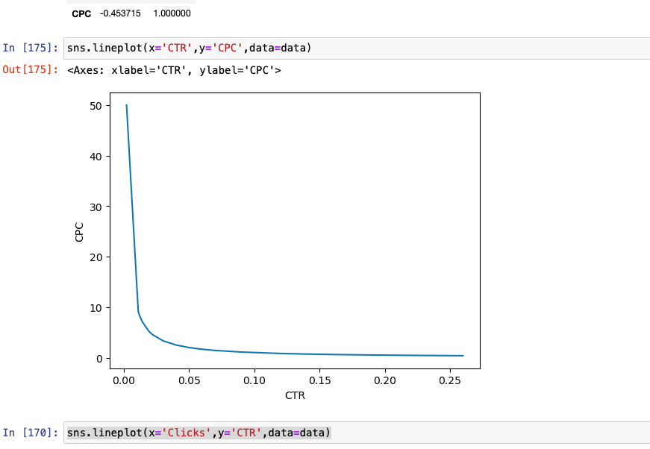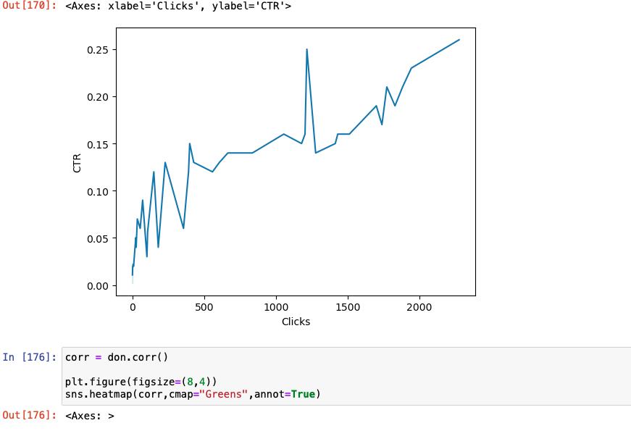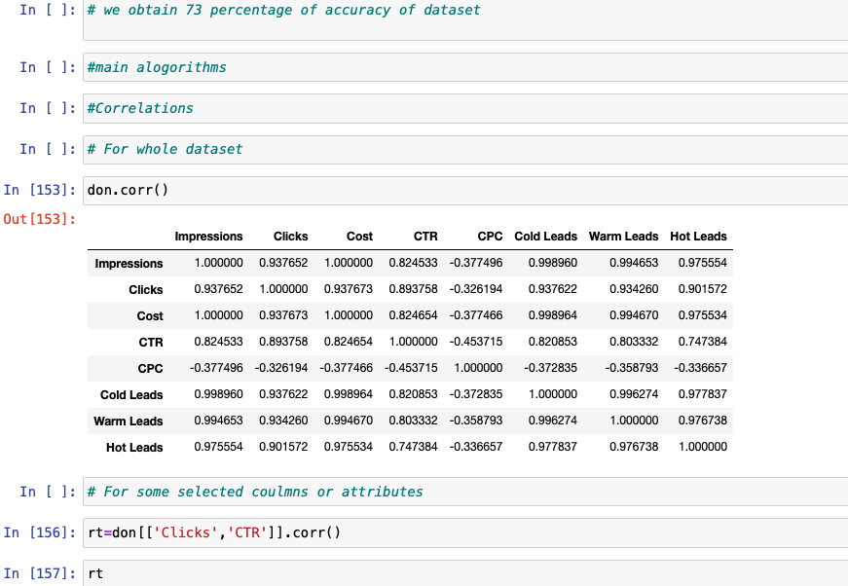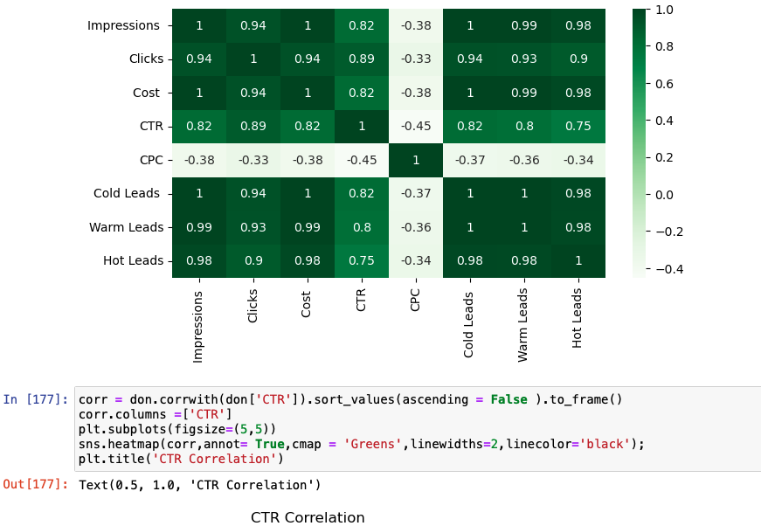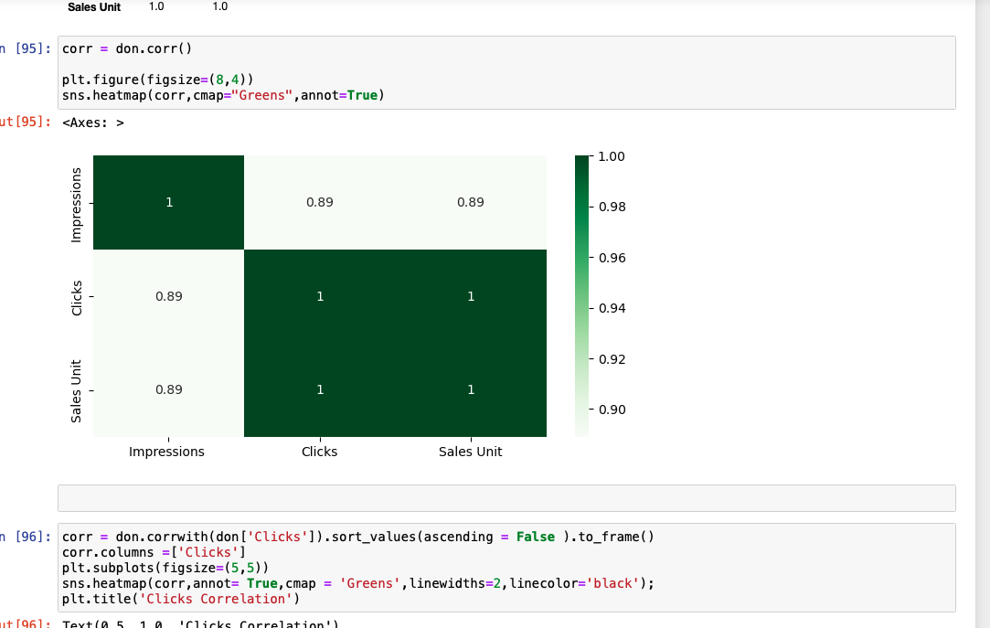

Exploratory data analysis.- Exploratory data analysis is an approach of analyzing data sets to summarize their main characteristics, often using statistical graphics and other data visualization methods. A statistical model can be used or not, but primarily EDA is for seeing what the data can tell us beyond the formal modeling or hypothesis testing task.

* Correlations
* Conclusion

Insights

Main Alogorithms

Insights

Correlations – relation between two variables .

**conclusion of analysis.**

#various phases of data analysis including data collection, cleaning and analysis are discussed briefly.

#Explorative data analysis is mainly studied here.

#For the implementation, Python programming language is used.

#For detailed research, jupyter notebook is used. Different Python libraries and packages are introduced.

# We can see that the Impression ,Clicks and Sales units there are interrelation between them

# we can see that when clicks increase Sales also increase .

# The clicks had the best sales.

# we can see that the DecisionTreeClassifier is used for accuaracy define in dataset

# we can see that hot leads correlation

# we can see that warm lead correlation.

# we can see that how the leads are relation between this cliks and impression

# we can see that when clicks increase Sales also increase .

# The clicks had the best sales.

# We can see that the linerregression to increase sales with increase the clicks and impression

# we can see that the average std deviation of impression very spread due to marketing canablize.

# We can see that the std deviation of clicks is some low than Impression because there is low awarnees of this ads.

# it is all about To analyses how many people who clicked on the advertisement enrolled in our course.

**Insights**

. In all about analaysis dataset to inform that general marketing and how the people was aware about advertisment

# this advertisment was 6th june.

# It main think that there was tuesday is a working day .

# people mindset was to do workholic or motivated

# that day they search or aware about cources

# some people was went house from office that time is about 12.am

# some people go to saw this particular ads but not click .

# to all dataset analysis there was impression was slightly peak but not click this ads .

# some people to aware this ads more information was find to click them this ads then this ads useful for this.

# those people want to sale this course.

# by the analysis is found that there is intereltaion between CTR, and CPC of paticualr advertisement

# and to analyais of what is hot leads and cold and warm leads genertion of particualar advertisement

#for the analysis there is 0.733 accuracy of data is obtained it menas that there is 73% customer refer or see the this advertsisment for course .

# i suggest to marketing head to increses ad. and disply reptabley for marketing and awaerness purpose .

# on the time which choose the have you leads like warm , cold and and hot lead which will be consider.

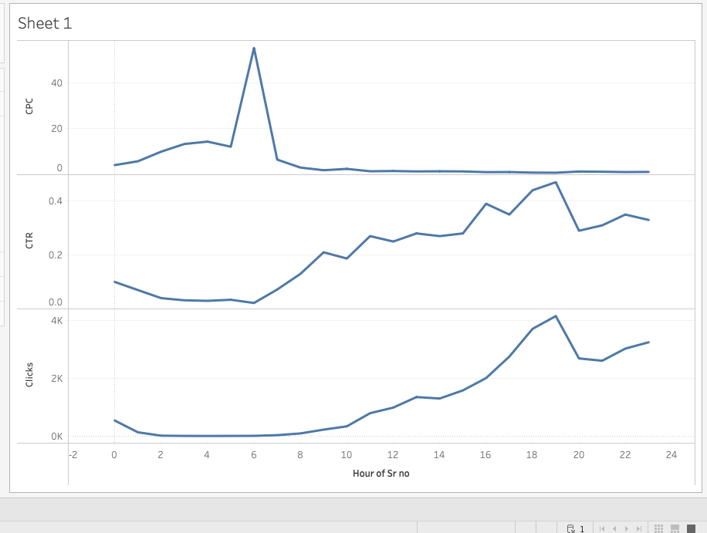

These insight which say that there is in day time CTR is increses continues. And cpc is low due to there is no customer sale low . I suggest marketing to study on Cpc which is some time is low . this is overall anlaysis of 19th June google ads.